Balachandran, Ryan 3/17/2022
Course Number: PHYS.1410L
Section Number: 804
Instructor: Dr. Mittler
Partners(s): Anthony, Brian, Ryan, Alyssa, Sophia, Justin

Motion on an Inclined Plane
Introduction
In this experiment, we studied the motion of an object moving on an inclined plane. The objective is to study, predict, and quantify the motion of objects down an inclined plane with respect to the angle, the force exerted on the metal car and the acceleration. The acceleration of the metal car down the incline will be measured as a function of the angle.

Theory
Consider a block of mass M on an inclined plane having $θ$ as the angle of the incline with respect to the ground, (assume no frictional forces).
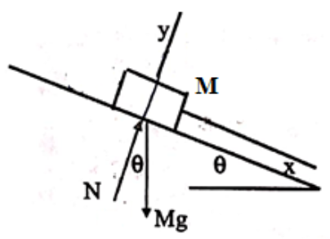
Note that the coordinate axes have been rotated by the angle $θ$ of the inclined plane so that the positive x direction is down the plane and the positive y direction is perpendicular to the plane. The free body diagram for the block indicates that there are just two forces acting on it:
N = normal force that is perpendicular to the inclined plane
Mg = weight of the block, vertically downwards
Let’s apply Newton’s 2nd Law to the block with the following two equations
$\sum{F_{x}=ma}$ and $\sum{F_{y}=ma}$
$mgsin\left(θ\right)=ma$ and $N-mgcos\left(θ\right)=0$
- $a=gsin\left(θ\right)………(1)$
From equation (1) it can be seen that the acceleration of the block depends only on the angle and it is independent of the mass of the block.
Suppose we consider the case where there is a frictional force between the block and the inclined plane.
$f_{s}≤μ_{s}N$ : Model used for static friction when there is no relative motion between the block and the plane
$μ_{s}≡coefficient of static friction$
$f_{k}≤μ_{k}N$ : Model used for kinetic friction when there is relative motion between the block and the plane
$μ_{k}≡coefficient of kinetic friction$
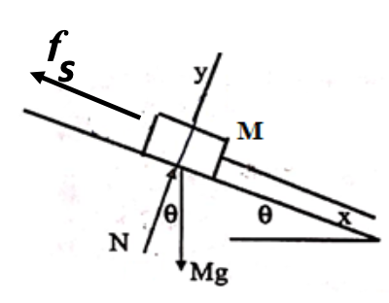
Let’s again apply Newton’s 2nd Law to the block when the angle is reached. This results in the following two equations:
$\sum{F_{x}=ma}$ and $\sum{F_{y}=ma}$
$mgsin$($θ)-f_{s}\left(max\right)=0$ and $N-mgcos\left(θ\right)=0$
Combing these two equations gives the following for the coefficient of static friction:
$$μ_{s}=tan\left(θ\right)………(2)$$
Apparatus and Procedure
Materials:
- Metal cart with force sensor
- Inclined Ramp
- Force-Incline program
- String to pull metal cart up

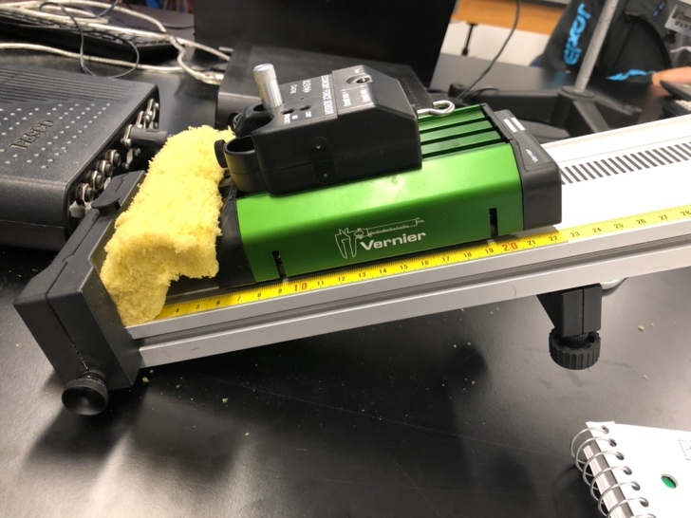
1. Metal cart with force sensor 2. Inclined ramp
Procedure
Initialization:
- In the Vernier folder open the Force-Incline program
- Turn on the motion sensor on the cart (button should turn blue)
- On Home page, Push START at the top of the page to begin testing
  - Move the cart up and down the ramp to verify the motion detector responds with a position value that varies
  - With the cart at the bottom of the track, push the Tare button on top of the force sensor
  - Press the ZERO button on the program
  - Pull the cart up by the string to verify the force sensor is responding
  - Press END to finish the sensor testing

For each run (part 1):
- On the acquisition page, set the ramp to the desired angle and enter the angle into the program
- Push the Tare button on the force sensor with it sitting at the bottom of the ramp
- Push the BEGIN button in the Force window and let it run until it stops (about 10 seconds) to verify the sensor zero is correct. (Should be less than 0.1N)
- Pull the cart up by the string and hold it motionless with the string parallel to the ramp.
- Push the BEGIN button on the Force window and wait for the measurement to stop.
  - If the deviation is less than 0.1N, proceed to next step, otherwise repeat this step
- Remove the string and place the cart near the top of the ramp and hold it there
- Press START and release the cart, then press END after the cart has reached the bottom of the ramp
- Accept the data if all steps have been completed correctly.

(Part 2):
- Click on Analysis/Single from the menu
- Select the data run
- Press ZOOM to view the entire graph
- Select the window with the desired data range and press ZOOM to limit your view to the correct portion of the graph
- In the velocity window, select a window with the data points you desire to use and press FIT
- If the fit appears good, press SAVE

Determine the mass of the cart:
- Click on Analysis/Combined from the menu
- Verify all valid runs are included
- Click FIT to obtain a linear fit to the data points
- Use a scale to measure the mass of the metal cart including the force sensor
- Make a comparison of the two values obtained for the mass

Results and Data

Angle | Acceleration (m/s) | Force (N)
5 | 0.75 | 0.6174
8 | 1.33 | 0.9683
11 | 1.68 | 1.1295
14 | 2.19 | 1.4609
17 | 2/74 | 1.7715
20 | 2.86 | 1.9827

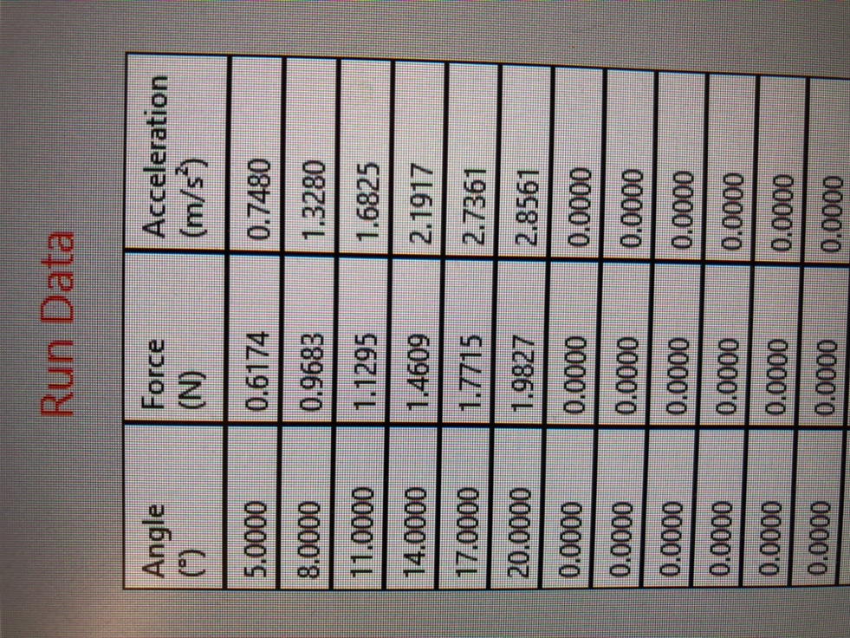
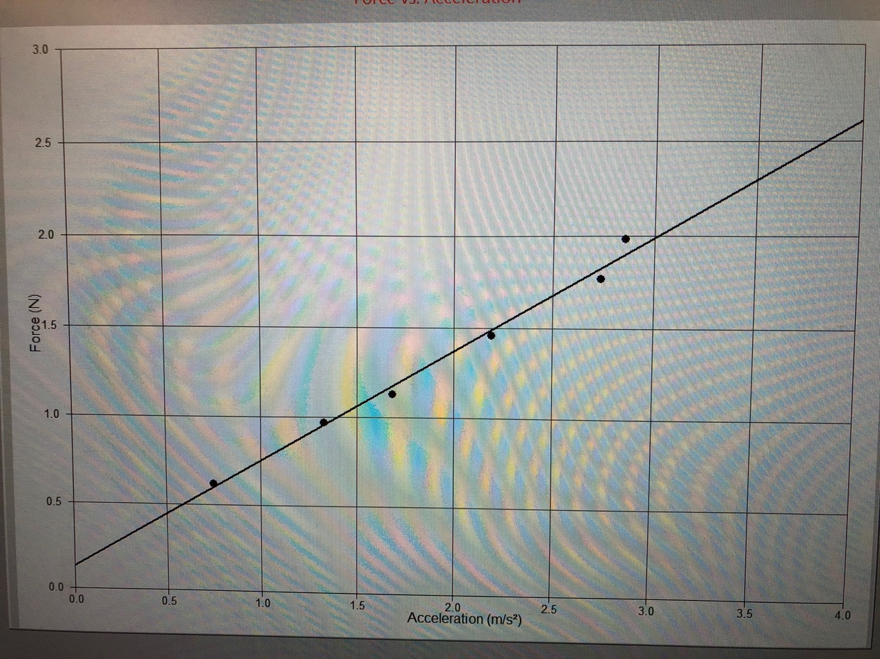
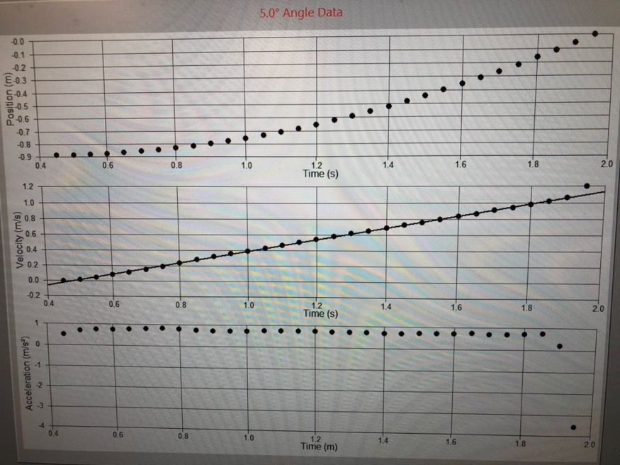 5 Degrees
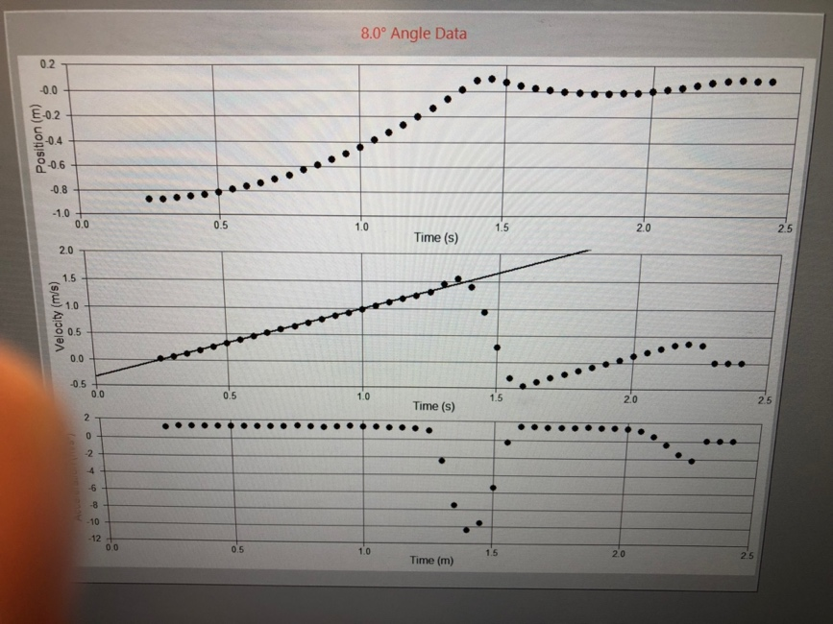 8 Degrees
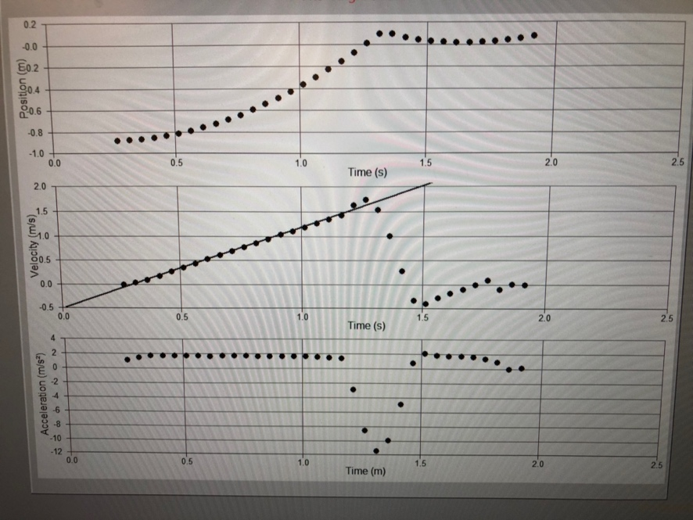 11 Degrees
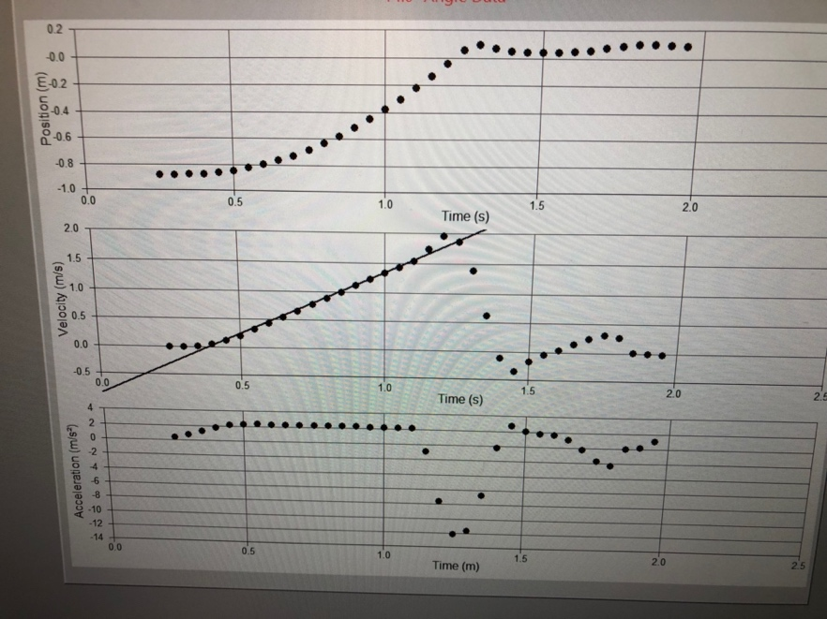 14 Degrees
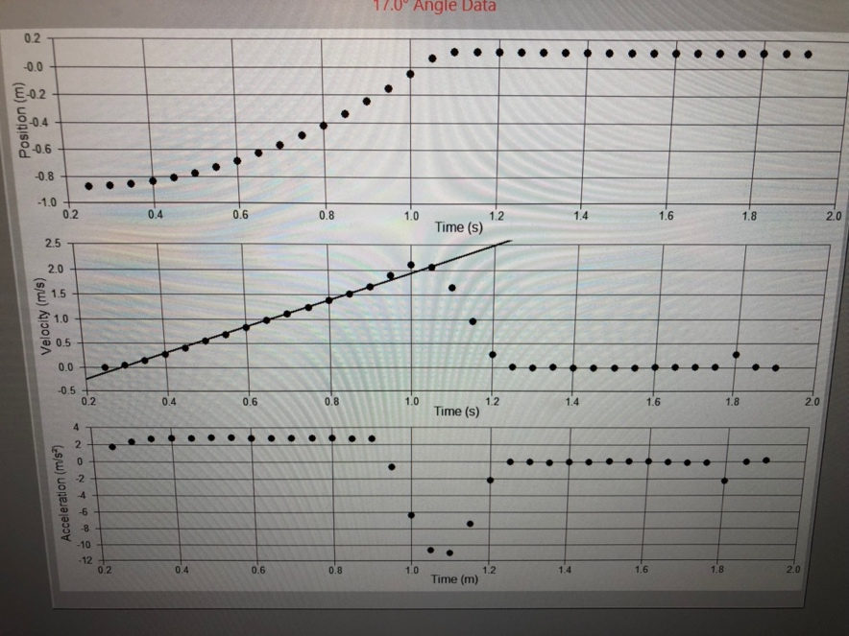 17 Degrees
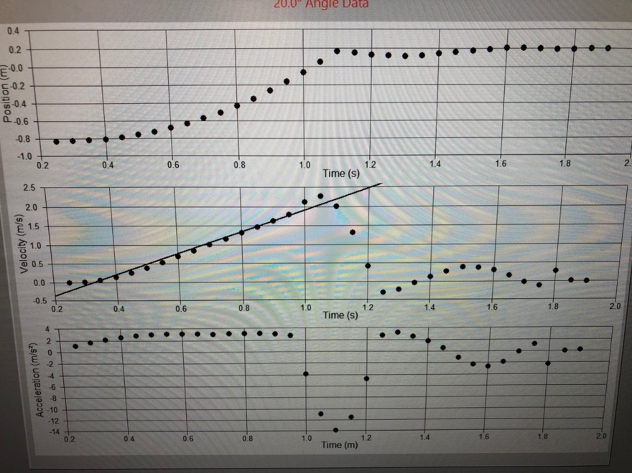 20 Degrees

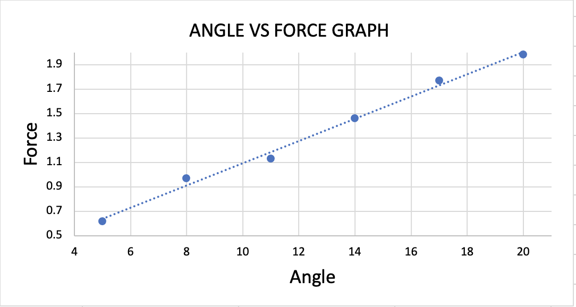

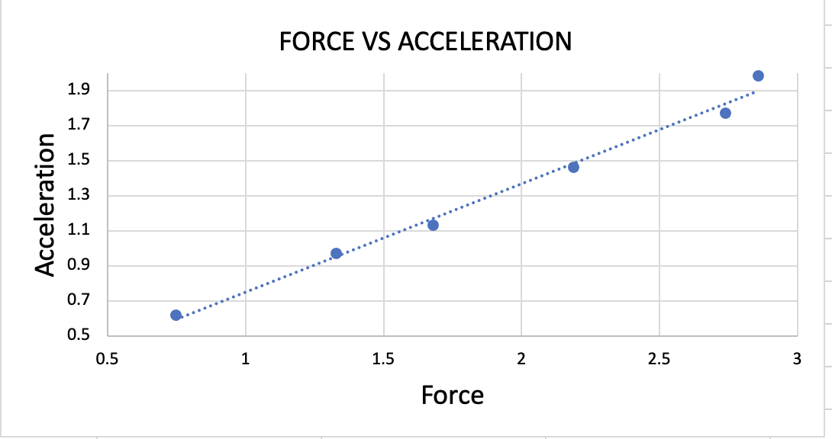

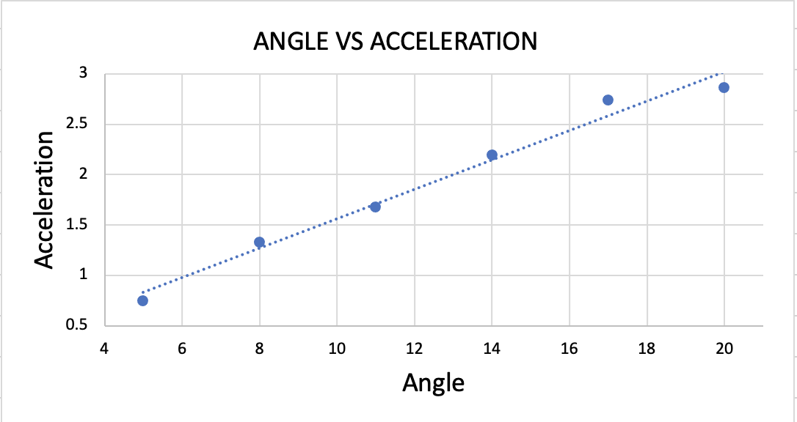
Analysis

The mass of the car was 658.3 grams, or 0.6583 kg. The fit result gave the weight of the car to be 0.619, which is off by about .40 kg.

As the angle of the incline increased, the force of the car ton the incline also increased linearly.
The velocity of the cart also increased linearly each time the angle of the incline was increased.

The graph we created from the data of acceleration and Force appears to be very similar, if not the same as the picture taken of the graph on the computer.

Discussion

The error percent of the mass of the cart was:

$$\frac{Actual value-expected}{expected}*100=\frac{0.6583-0.619}{0.619}*100=6.35\%$$

We did not have any difficulty when performing this experiment except for the fact our position value was negative for some reason. This did not however, affect our results.

Conclusion

The overall goal of the experiment was to study the motion of an object on an inclined plane. Given a set of angles, we determined the force in relation to the angles on a cart that sat on the incline and the velocity once it was released from the top.

Questions

Run | Initial Velocity (m/s) | Gravity (m/s²) | Mass (kg) | Coefficient of Static Friction | Coefficient of Kinetic Friction | Angle
1 | 0 | 9.81 | 5 | 0 | 0 | 10
2 | 0 | 9.81 | 5 | 0 | 0.5 | 26.56
3 | 0 | 9.81 | 5 | 0.25 | 0.5 | 26.566

Run 1: Acceleration was a constant 1.702 m/s²

Run 2: Find maximum angle where the block will not move: At angle 26.56, the block will not move.

From angle, calculate $μ_{s}.$ $μ_{s}=tan\left(θ\right)=tan\left(26.56\right)=0.499988$
Run 3: Find the approximate minimum angle where the block begins to move. At angle 26.566, the block will begin moving with an acceleration of 2.192 m/s².

With the coefficient of static friction set at 0.5 and the coefficient of kinetic friction at 0, the acceleration is 4.383 m/s², but when the kinetic friction is increased to 0.25, the acceleration is halved. For each increase in the angle, the acceleration increases between 0.1 and 0.3 m/s².

